Andre Floyd

Ryan Len

Vinson Dinh

CIS 436 P3 Screenshots

Starting Screen

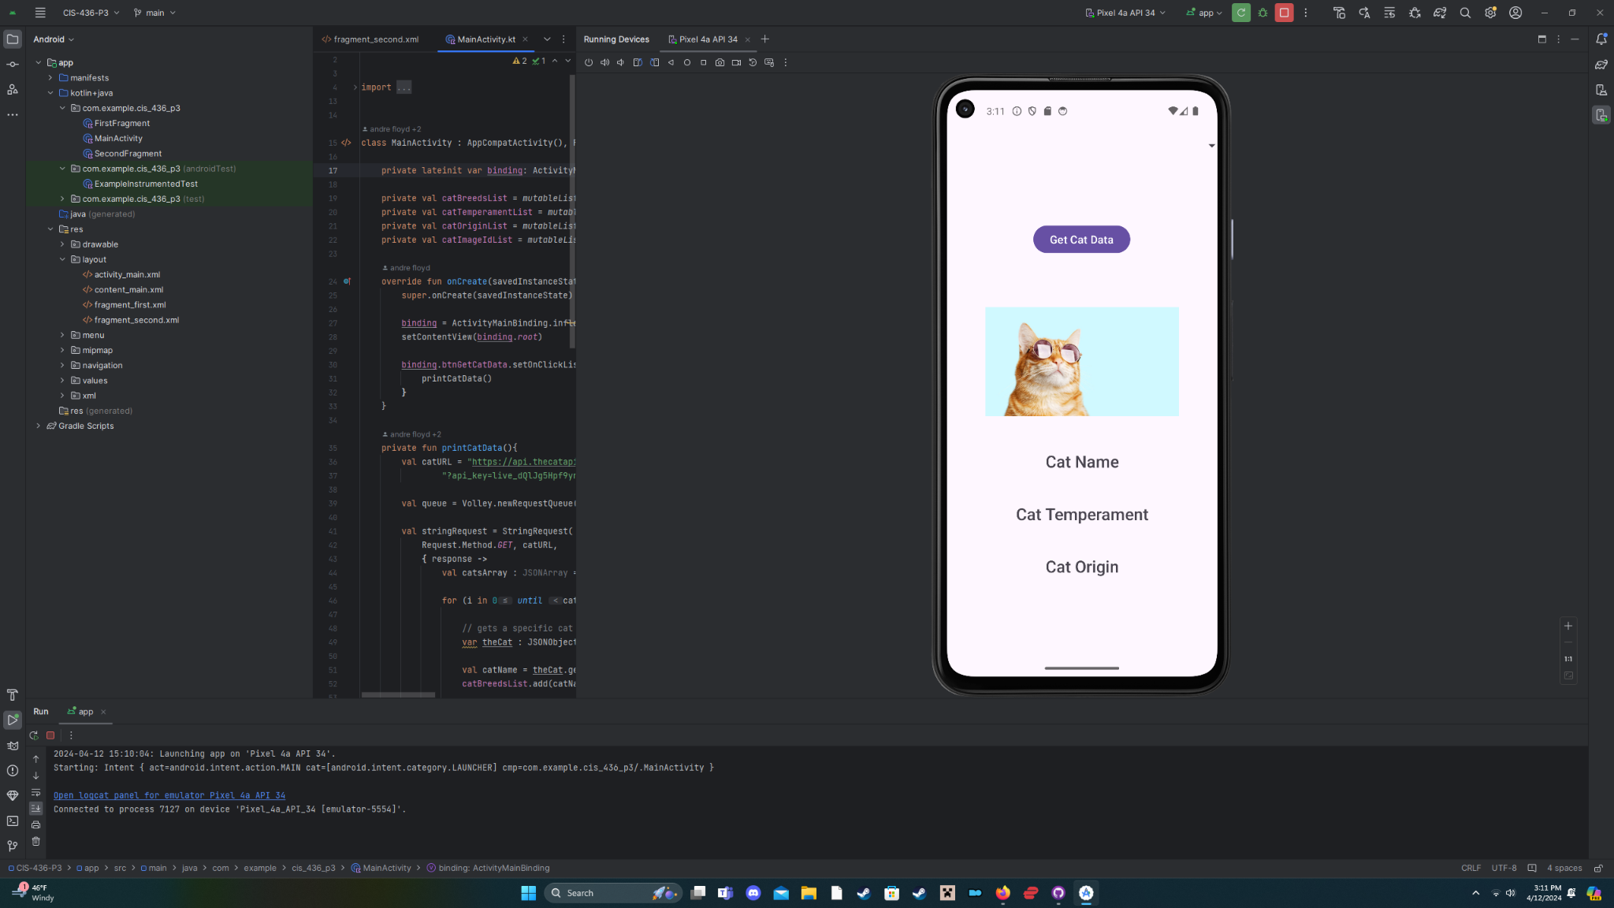

Cat Dropdown List

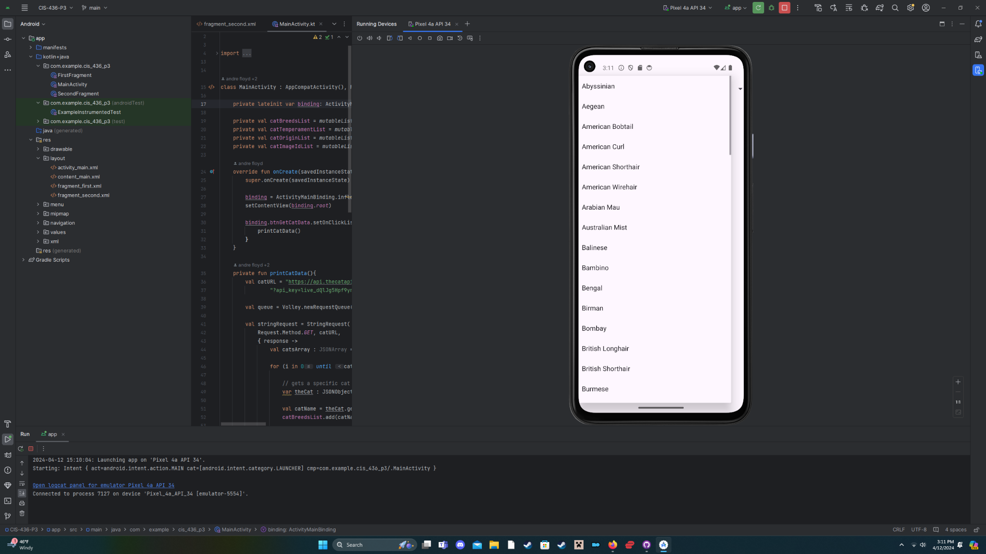

Example #1 Dragon Li

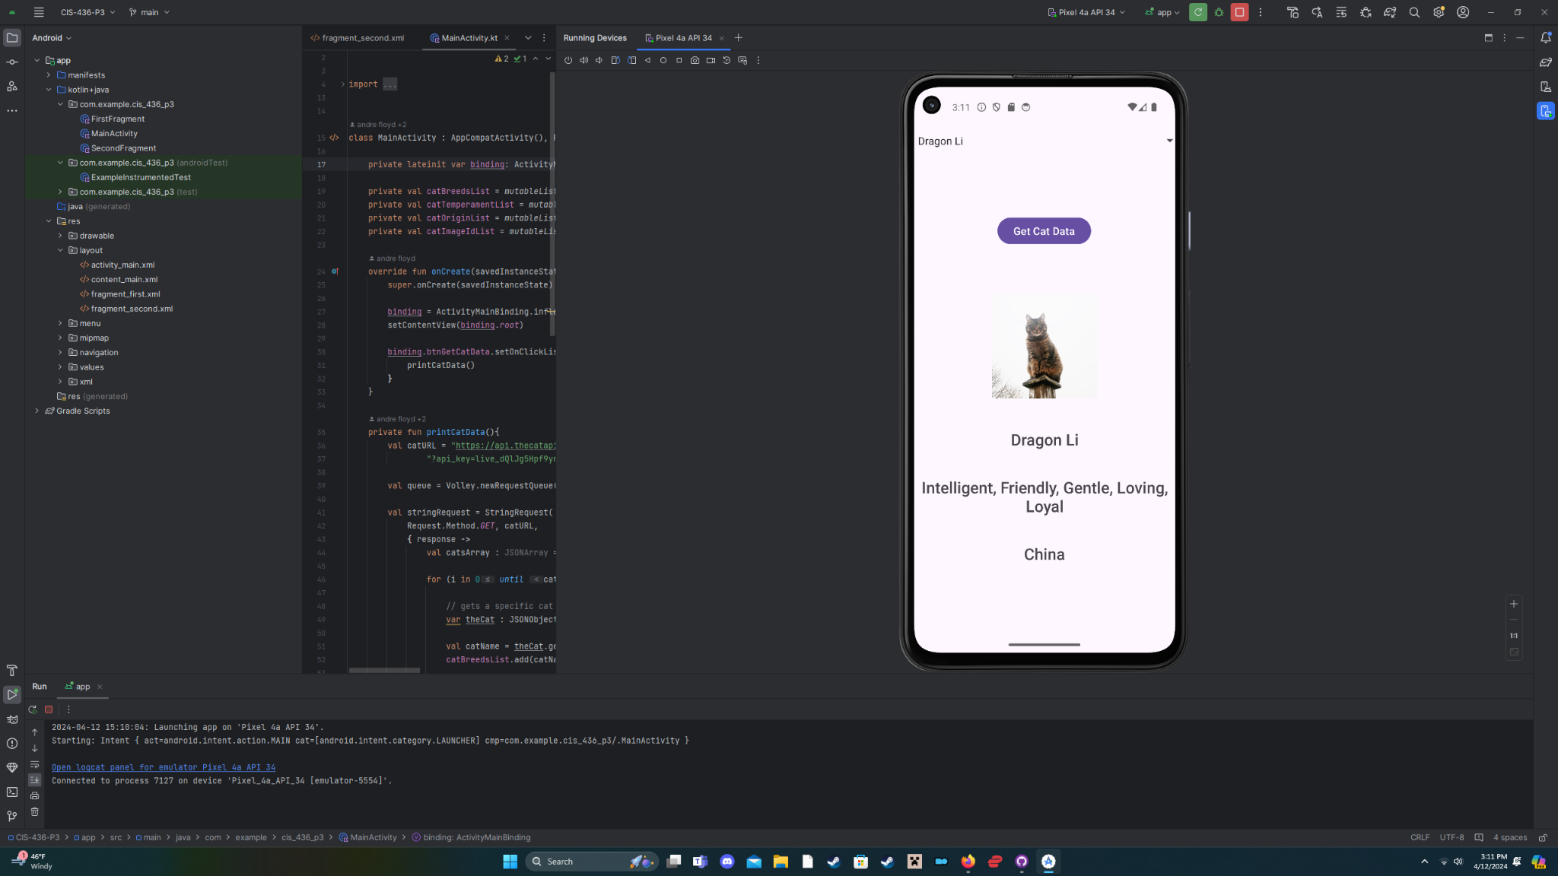

Example #2 Abyssinian

